DAOS Mapping

The central paradigm for mapping HDF5 to DAOS is that HDF5 files are stored as DAOS containers, and HDF5 objects (groups, datasets, named datatypes, and maps) are stored as DAOS objects, both using a 1:1 mapping. All metadata and raw data associated with an HDF5 object is then stored as entries in the key value store associated with that object provided by DAOS.

Since DAOS containers are identified by a UUID, the plugin uses a hashing function to generate a UUID from the file name. Each container for an HDF5 file contains at least two objects: the global metadata object and the root group. The global metadata object stores metadata that describes properties that apply to the entire file. Currently this is only the maximum object id. The root group is always the start of the HDF5 group structure, and uses the same format as all other groups.

Similar to the native HDF5 file format, the formats for the different object types are kept similar, with only differences as necessary to represent the specific object type. All object types have a creation property list and a reference count (not yet implemented) stored under the “/Internal Metadata” dkey and the “Creation Property List” and “Reference Count” akeys, respectively. All object types also have attributes stored under the “/Attribute” dkey. Each attribute stores its datatype under the “T-<attribute name>” akey, its dataspace under the “S-<attribute name>” akey, and its value under the “V-<attribute name>” akey.

Groups

The purpose of HDF5 groups is to store links to other objects, and each of these is stored under a dkey, which equals the link name, with a constant akey (“Link”). Links can be hard, in which case it contains the object id for the target, which can then be directly opened, or soft, in which case the link contains the path name of the target, which must be traversed to open the target.

Figure 4-8. Group Dkey and link examples
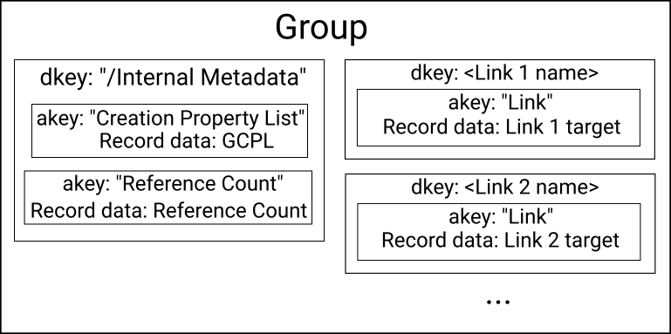
Datasets

Datasets are used to store the bulk array data in HDF5. In addition to the creation property list, these store the datatype and dataspace under the “/Internal Metadata” dkey and the “Datatype” and “Dataspace” dkeys respectively. Raw data is divided into “chunks” which are regularly spaced blocks of data, where the size of the block is specified by the application. Each chunk is stored in its own dkey. The dkey is encoded with a leading 0 byte, followed by <number of dimensions> 64 bit little endian unsigned integers which denote the chunk offset within the dataset. The “/” prefix for internal metadata and attributes prevents conflicts with arbitrarily named links, which cannot contain the “/” character, and the 0 prefix for chunks prevents the binary chunk dkeys from conflicting with the string metadata dkeys, since nonzero length strings cannot begin with 0 (‘\0’).

For datasets with fixed length datatypes, the data for the chunk is stored in a single akey (with a value of a 0 byte), as an array of records, where each record corresponds to an element in the dataset. The record size is therefore equal to the size of the datatype and the number of records is equal to the number of elements in the chunk. For datasets with variable length datatypes, each element is stored in a separate akey, as a single record, whose size i equal to the total size of the variable length element.

Figure 4-9. Fixed Length Dataset Dkey and link examples

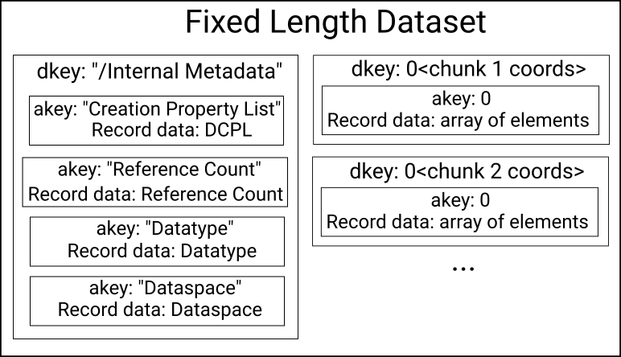
Committed Datatypes

Committed datatypes are an HDF5 datatype that has been stored as an HDF5 object in the group structure. The only object type specific data is the datatype itself, which is stored similarly to that of datasets, under the “/Internal Metadata” dkey and “Datatype” akey.

Map Objects

Map objects are an HDF5 object that contains an arbitrary application-defined key-value store. The map’s key and value datatypes are stored under the “/Internal Metadata” dkey, and under the “Key Datatype” and “Value Datatype” akeys respectively. Values are stored under a dkey which is equal to the binary representation of the key, and under a constant akey (“Map Record”).

Object Ids

DAOS objects are referenced through the DAOS API by a 192 bit object ID. Only the lower 64 bits are currently used by HDF5, the rest of the ID is set to 0 and/or set by DAOS to encode the DAOS object class, which is always the same for each HDF5 object type. The lower 62 bits are simply set in increasing order, starting from 1, which is always the root group (0 is reserved for a global metadata object). The remaining 2 bits are used to encode the HDF5 object type. This
removes the need to store the object type in the key-value store for the object itself, and allows the plugin to determine the object type and therefore the routines used to access it without needed to query DAOS, reducing the number of server requests needed for metadata operations. The lower 64 bits (including the encoded object type) are considered the “address” for the purposes of the HDF5 API, and is what is returned as “addr” from H5Oget_info and what is accepted for H5Oopen_by_addr.

Object ID allocation is currently not handled correctly when done independently by multiple processes. This is a temporary solution until a DAOS object ID allocator is available. This means that either all objects should be created by the same process, or they should always be created collectively using H5Pset_all_coll_metadata_ops().

